Tab 1
About Us-Overview

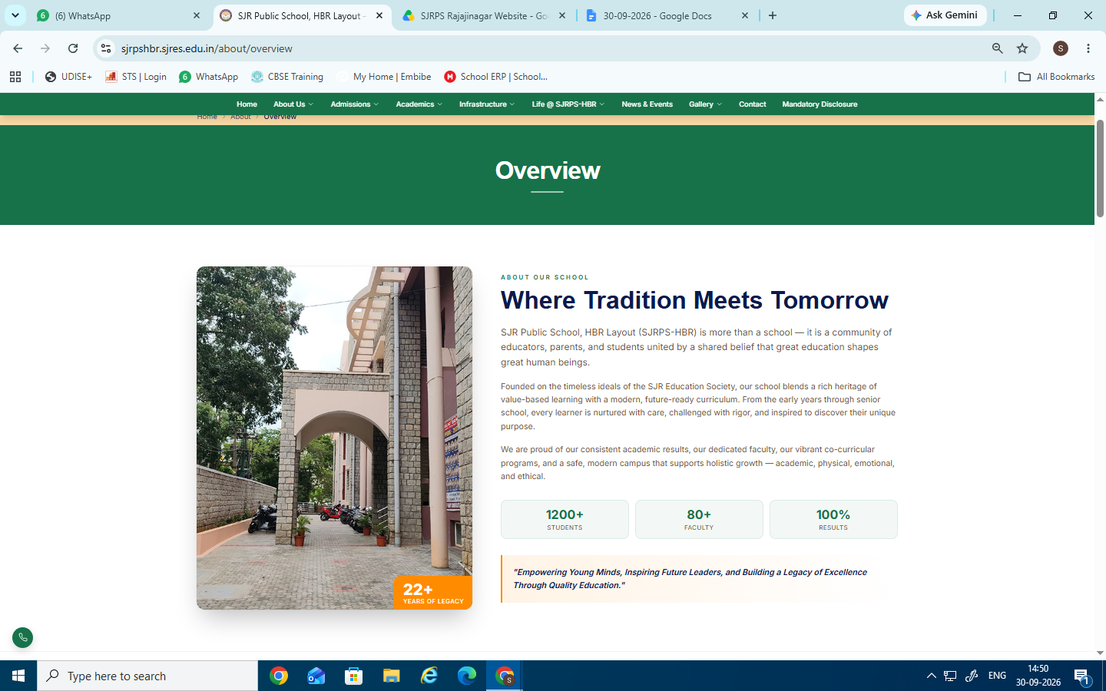
Changes to be done
About Our School

Where Tradition Meets Tomorrow
SJR Public School, Rajajinagar (SJRPS-PS) is more than a school — it is a community of educators, parents and students united by a shared belief that great education shapes great human beings
Founded on the timeless ideals of the SJR Education Society, our school blends a rich heritage of value-based learning with a modern, future-ready curriculum. From the early years through senior school, every learner is nurtured with care, challenged with rigor, and inspired to discover their unique purpose.We are proud of our consistent academic results, our dedicated faculty, our vibrant co-curricular programs, and a safe, modern campus that supports holistic growth — academic, physical, emotional, and ethical.
1000+ Students 50+ Faculty 100% Results
"Empowering Young Minds, Inspiring Future Leaders, and Building a Legacy of Excellence Through Quality Education."
- School Photo has to changed (Present under Home page photos folder)
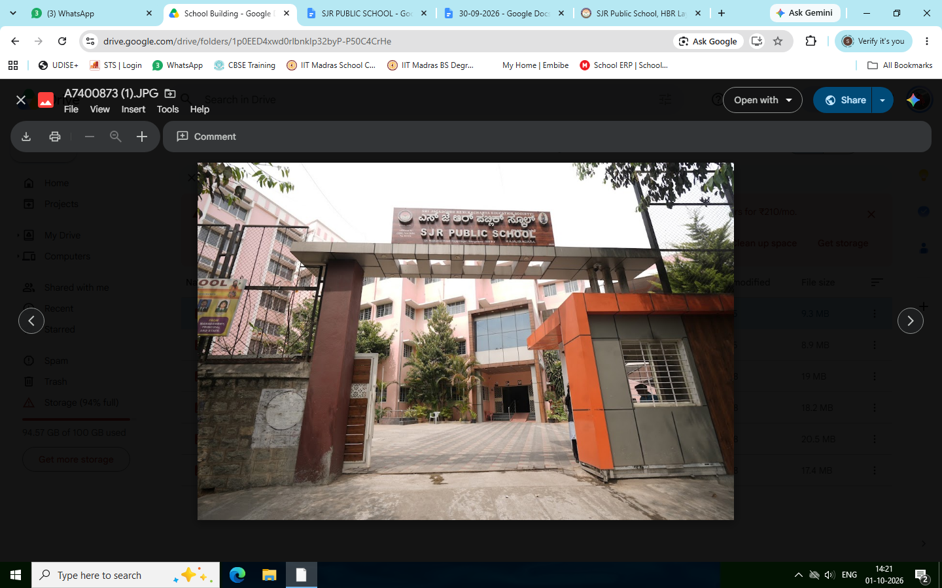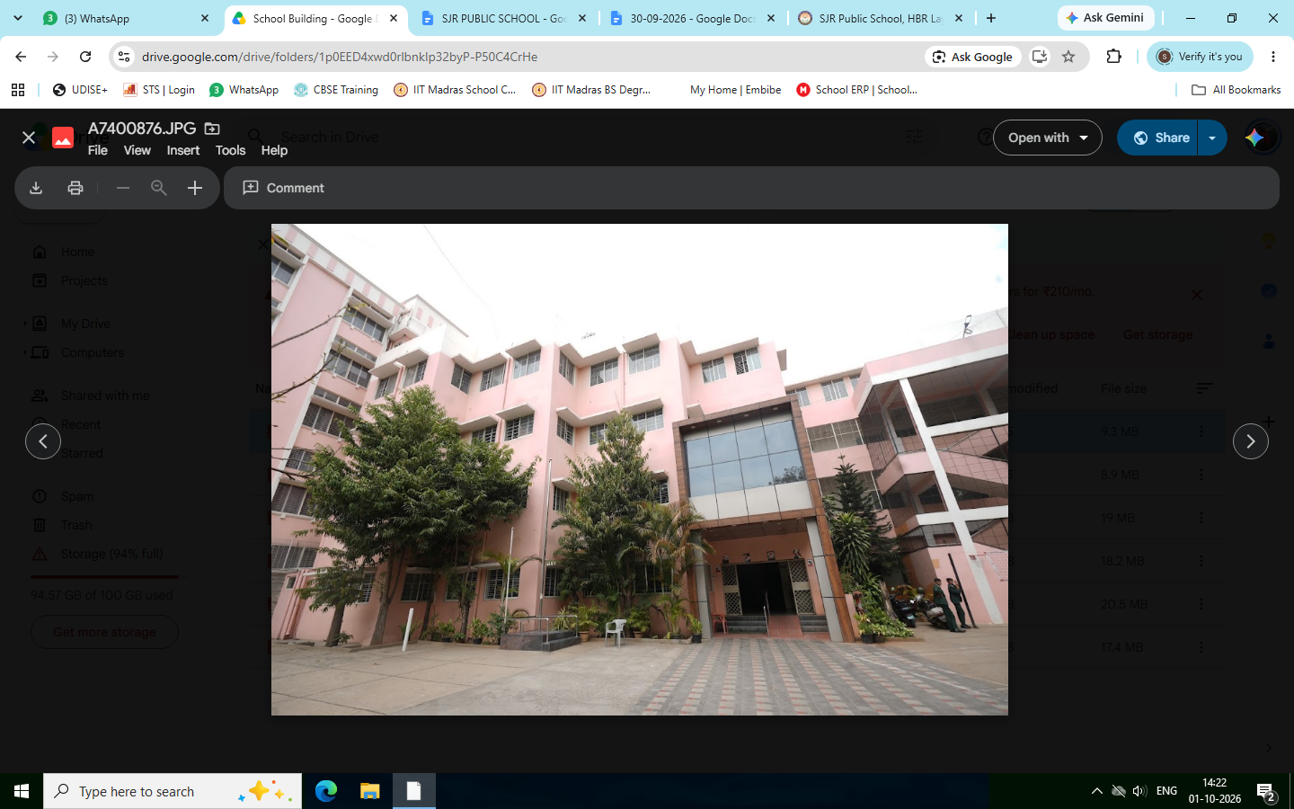
Refer the photo (School building)

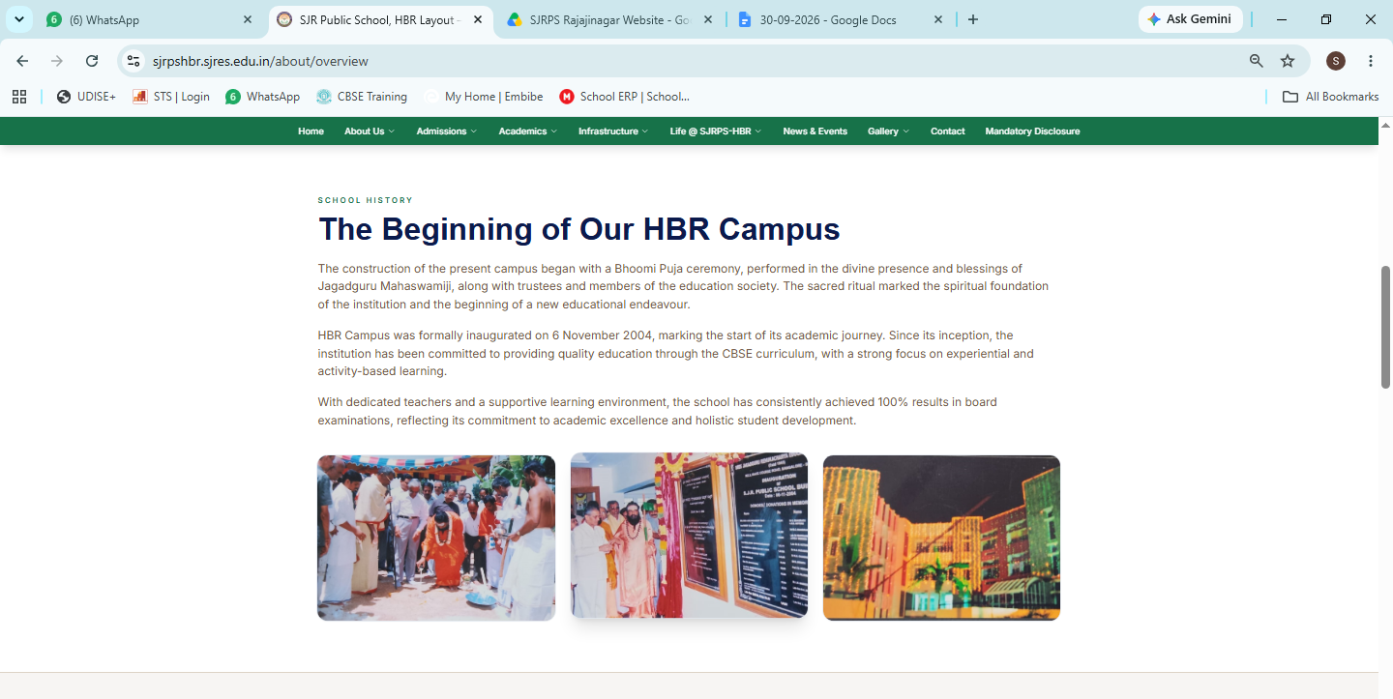
- Information to be updated - Photos are in the old photos folder.
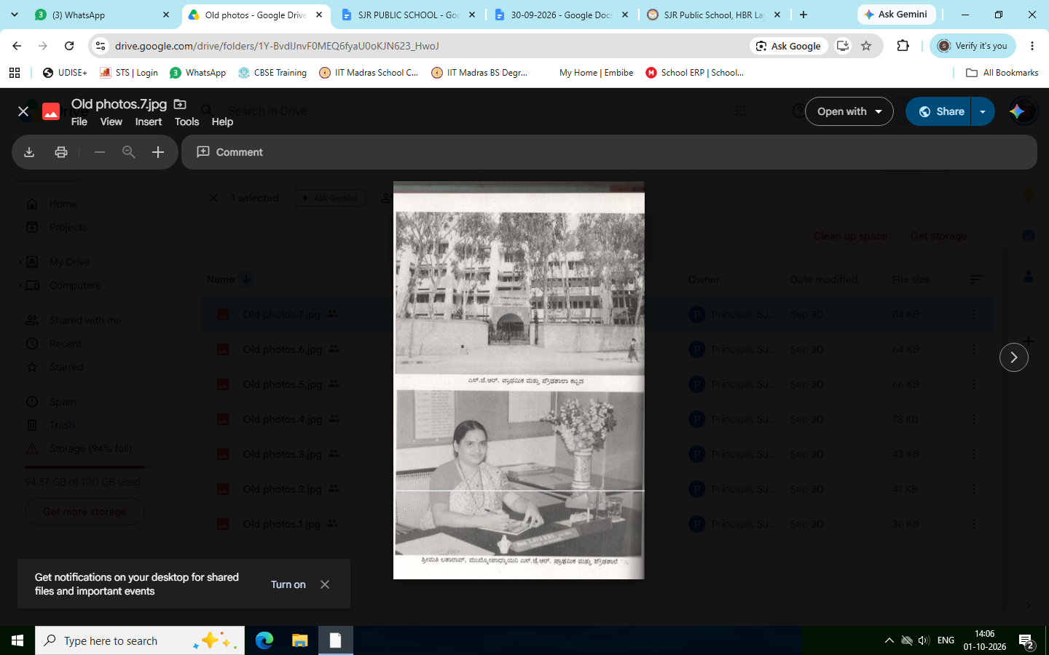
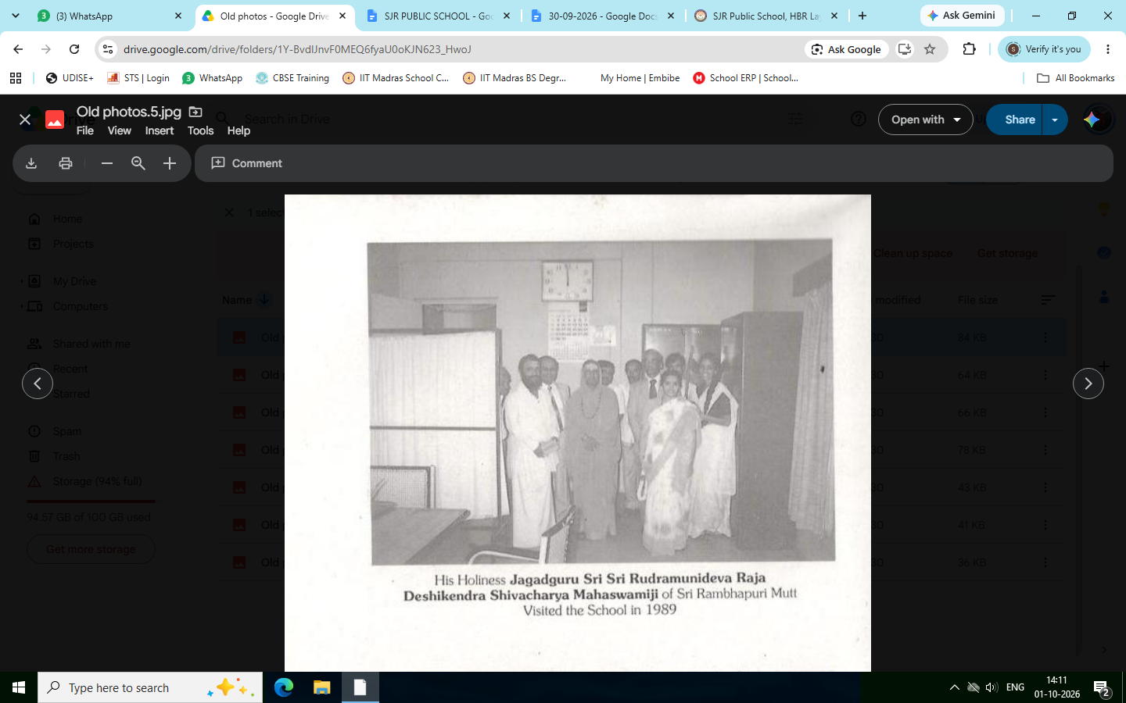
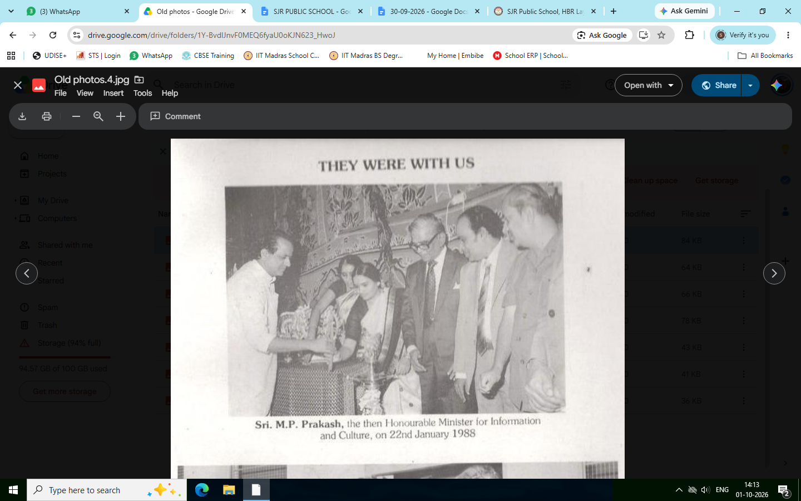

The Beginning of our Rajajinagar campus
Rooted in a rich legacy of education, the Rajajinagar campus began its journey in 1951 with a simple yet powerful vision—to provide quality education and lay a strong foundation for the generations to come.

The Society, which had been functioning as a collegiate institution since 1945, ventured into school education in May 1981 by establishing a nursery and primary school in a temporary shed at the S.J.R. Law College Hostel area. The school began with L.K.G. and 1st Standard.

The institution grew steadily, with U.K.G. and II Standard introduced in 1982–83, followed by the addition of one higher standard each year from 1983–84. The introduction of X Standard in 1990–91 marked the completion of the school’s primary and high school sections.

A significant milestone was reached in 2022–23, when SJR Primary and High School transitioned from the State Board to the Central Board of Secondary Education (CBSE) and was renamed SJR Public School. The school adopted the NCERT-based curriculum, with an emphasis on academic excellence, skill development and holistic learning.

Today, SJR Public School Rajajinagar, continues this legacy by combining its rich heritage with a progressive approach to education, nurturing confident, responsible and future-ready learners.

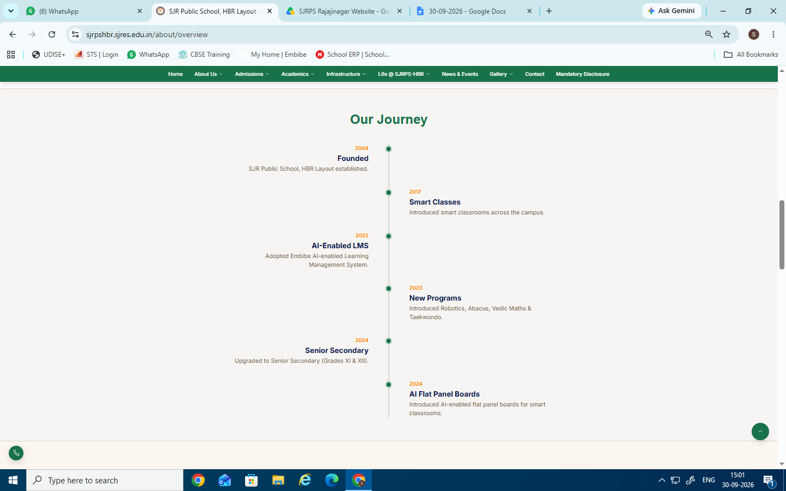

Our Journey
- Founded 1981(SJR Primary and High School Established)
- 2017 - Smart Classes
- 2022 -SJR Primary and High School transitioned from the State Board curriculum to the Central Board of Secondary Education (CBSE)
- 2023- New Programs -Introduced Robotics, Abacus, Vedic Maths, Embibe & Taekwondo.
- 2024 - AI Flat Panel Boards Introduced AI-enabled flat panel boards for smart
classrooms.
- 2025- Implement Enterprise Resource Planning (ERP) System.

About Us-Vision & Mission
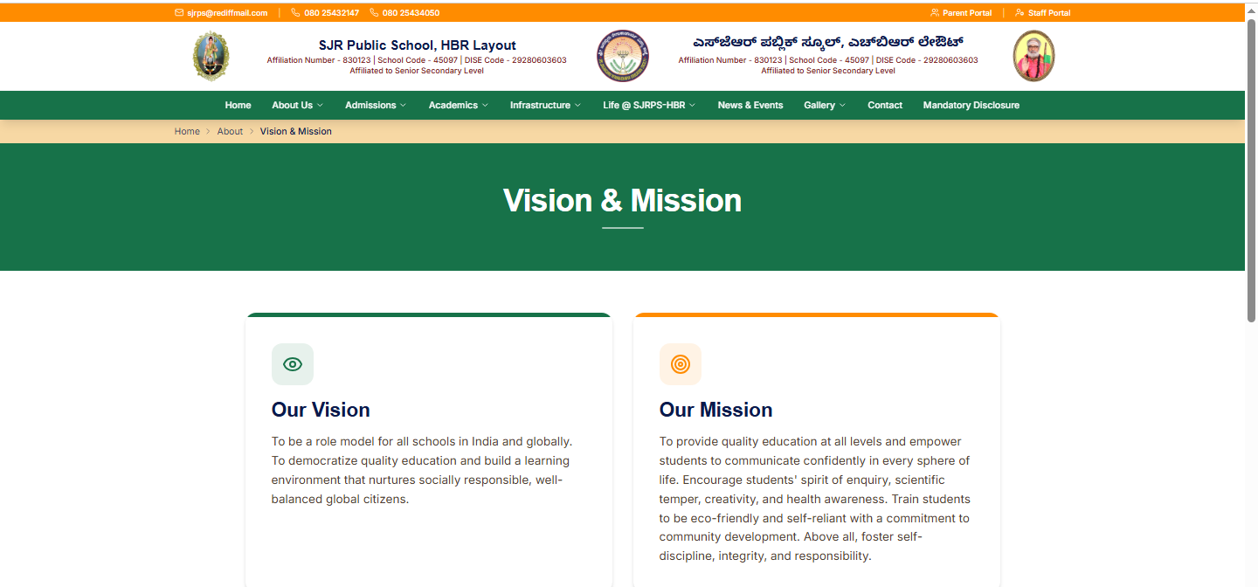

Mission Vision has to be changed
Mission

To nurture diverse talents in the varied forms of art , music , dance and sports in addition to excellent academic process , thus promoting the all round development of each child

Vision
To offer a nurturing learning environment where the social ,physical , emotional and intellectual needs of children are fulfilled, thereby enabling them to grow holistically in every sense.

Retain Other content

About Us-Principal’s Message

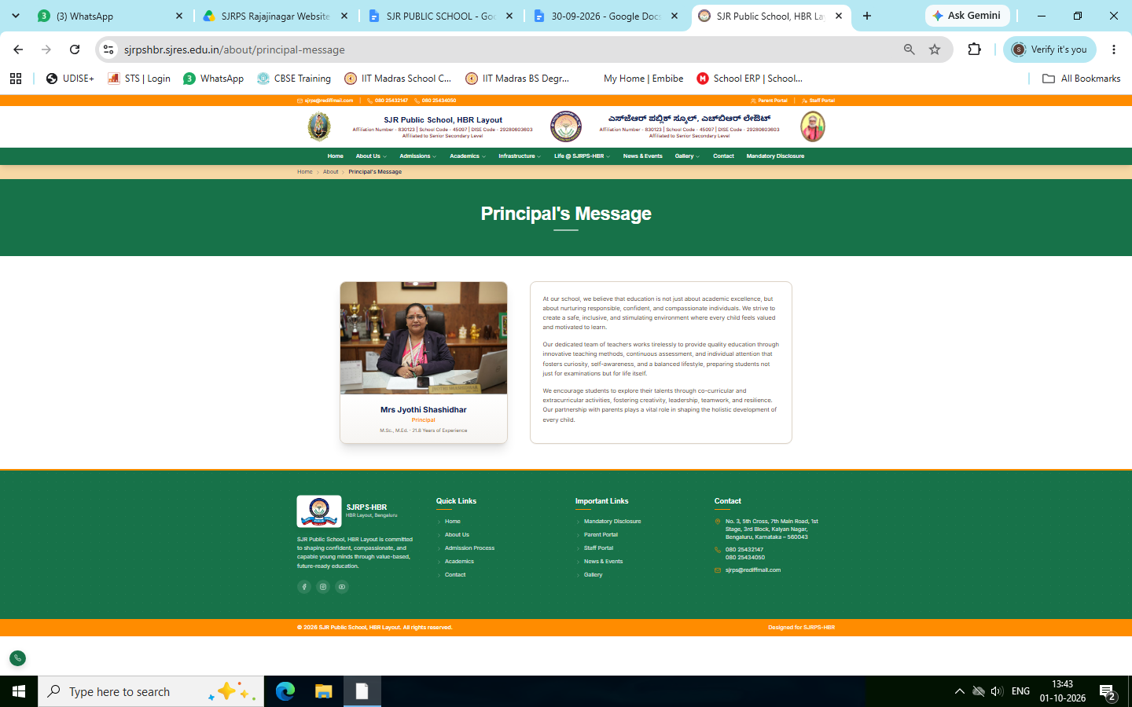
Changes to be done
- Principal Photo (In Staff Photo folder)
- Principal Details (In Staff details Excel Sheet)
- Principal Message has to be changed

“Education is not merely about preparing a child for examinations; it is about preparing a child for life.”

Vision:
To nurture confident, compassionate and responsible individuals who learn with purpose, live with integrity and grow into capable, resilient and lifelong learners.

Mission:
We at SJR are committed to provide every child with meaningful learning, strong values and emotional well-being in a safe and supportive environment. We identify and nurture each child’s unique potential, develop character and life skills and prepare for a successful, fulfilling and responsible life.
“Every Child Matters, Every Journey Matters, Every Future Matters.”

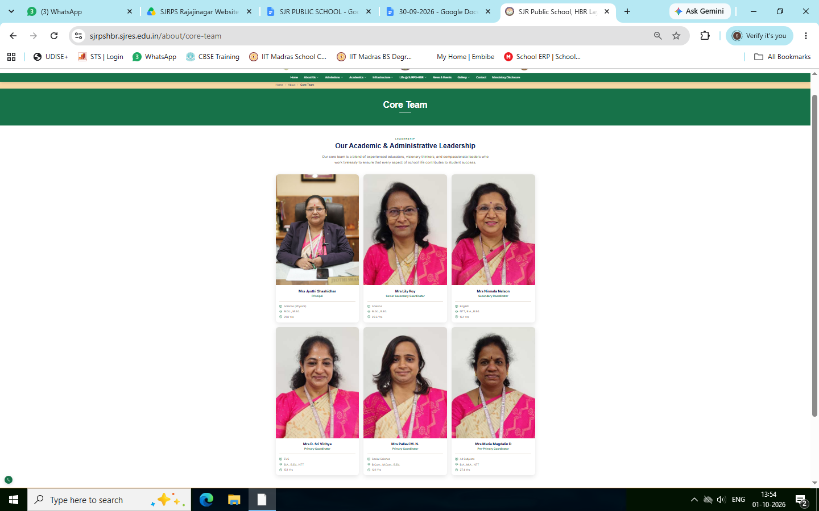
- Details and Photos of Principal and coordinators has to be changed (Present in Core team folder)

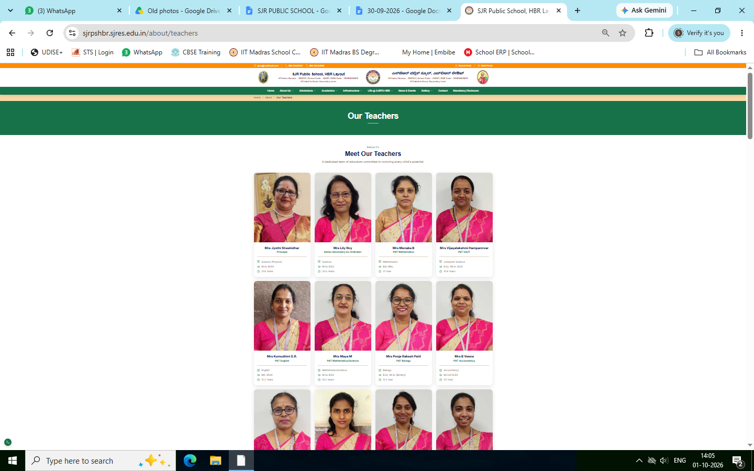Teachers and office staff update has to be done (Present in Staff photos)

